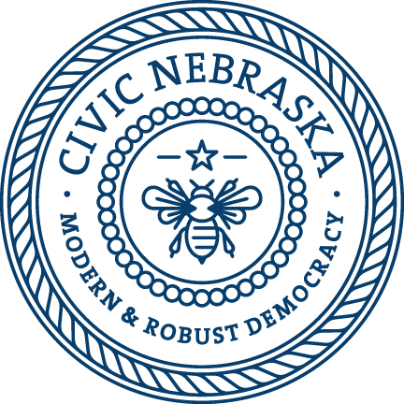

What is service learning?

Service learning is a teaching strategy that integrates service to a community with
academic standards. Students participate in authentic service, their voice is present, they reflect throughout, and they collaborate with stakeholders to complete a meaningful project. Through these projects and together with partners, students will gain valuable civic leadership skills while performing meaningful work in their community. These projects:
• meet authentic community needs
• develop leadership skills
• address academic standards
• provide structured time for students to reflect
• foster a lifelong commitment to service for the community
• include essential elements of meaningful service learning

The steps and components of service learning

- Students have a voice in determining an authentic project focus
- Community partners are located and enlisted
- Students and partners collaborate to create a plan
- The teacher will find or create links to academic standards
- Students will reflect throughout the project in a variety of ways
- The plan is implemented
- Results are assessed and celebrated
What types of outcomes can be expected?

- direct service-students interact personally with the people benefitting from the service
(students record the life stories of elderly people and compile a book)
- indirect service-students work to support people or an issue that is remote
(students study water in biology, then fundraise to dig a well in Malia)
- advocacy-students promote action on an issue
(students study domestic animals and have a “spay your pet” drive)
- awareness-students work to raise community awareness of an issue
(students test groundwater and have a campaign on the dangers of pesticides)

Service learning enhances:

- Critical thinking skills – identifying issues and analyzing them from various perspectives
- Problem solving skills - exploring how problems can be solved in multiple ways
- Collaboration skills - students will work with a variety of partners on a single issue
- Contextualization skills - students will relate problems and solutions to their community

