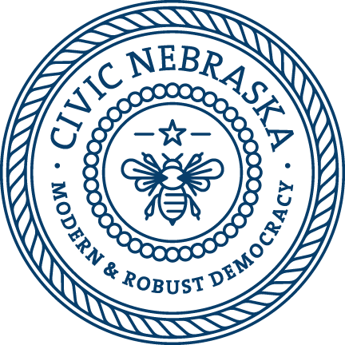

Youth Scholarship
Civic Nebraska maintains a scholarship fund to benefit families in need as their child participates in our Before- and After-School Programming.
To be considered for a scholarship, complete this form and submit it with proof of income (most recent 3 paystubs or income tax return).
Parent/Guardian Name:______________________________________________________
Phone:___________________________________________________________________
Child's Name:_____________________ Date of birth:____________________________
Child's Name: ____________________ Date of birth:____________________________
Location of Program:_________________________________________________________
Gross Yearly Household Income: _______________________________________________
Size of Household: __________________________________________________________
Statement of Need: __________________________________________________________
__________________________________________________________________________
Office Use Only
Income Verification: ☐ 3 Pay Stubs ☐ Tax Return
Program: __________________________________________________________________
Scholarship Amount: _________________________________________________________
Family Obligation:____________________________________________________________

